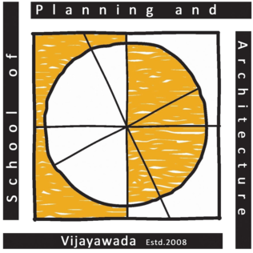 | School of Planning and Architecture: Vijayawada
 | (An institution of National Importance under the Ministry of Education, Govt. of India)
 | Survey No.4/4, ITI Road, Vijayawada-520008, Andhra Pradesh, India
Department of Architecture | Hindi
Course: |  | Class: I Year - I Semester 2026
Instructors: | K Harish Kumar | Internal Assessment: 25
Instructors: | K Harish Kumar | External Theory Exam: 25
Contact Periods/ week: 03 periods. (55 min each) |  | Total Marks: 50
Time Table: | Wednesday (03 periods) | Credits:
Objective: To improve the ability to understand, speak, read, and write Hindi by studying Hindi as an elective subject.

Week | Lecture Plan | Remarks/Topic of Assignment
Week 1 | Importance of Hindi and self-introduction by the students in Hindi. | Discussion
Week 2 | Introduction of Basics of Hindi along with Hindi वर्णमाला, | Lecture + Discussion
Week 3 | Exercises and practice of Present tense, Past tense and future tense of Hindi | Lecture + Discussion
Week 4 | Case endings like क, की, के, ने, में etc. | Lecture + Assignment
Week 5 | Hindi Terminology, Hindi words and phrases and etc. | Lecture + Discussion
Week 6 | Translation of Hindi sentences | Lecture + Assignment
Week 7 | Introduction of Hindi Genders

Week 8 | Exercise of Hindi letter writing | Lecture
Week 9 | Exercise of Hindi Precis writing | Lecture + Discussion
Week 10 | हिन्दी व्याकरण, Practice of Hindi Speaking, Writing and Reading. | Lecture + Student Activity

S. No. | Stages of Evaluation | Weightage
1 | Internal Assessment | 25
2 | External Assessment | 25
 | Total | 50
Course Instructor:  sd/-  (K Harish Kumar, Hindi Consultant) |  | Head of Department :  sd/-  (Dr. Amitava Sarkar)

